1.TO CONVERT A DECIMAL NUMBER TO BINARY NUUMBER:

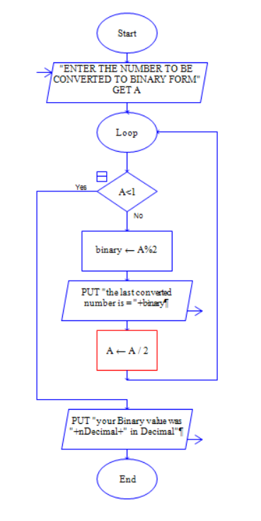

2.READ THE NUMBER AND FIND ITS SQUARE:

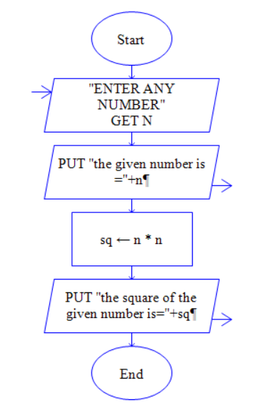

3.TO FIND BIGGEST OF THE THREE NUMBERS:

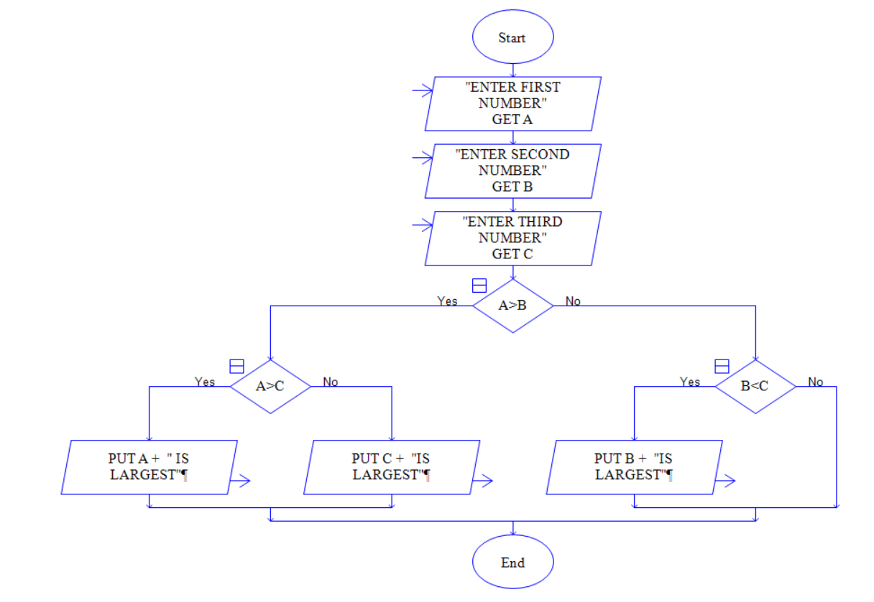

4.TO FIND LEAP YEAR OR NOT:

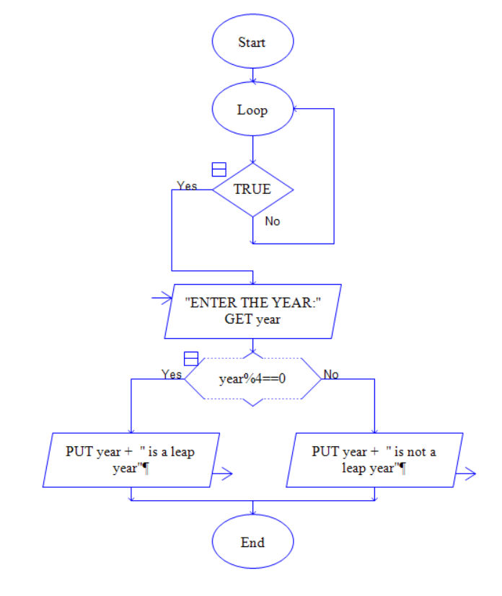

5.TO PRODUCE MARK LIST OF THE STUDENT:

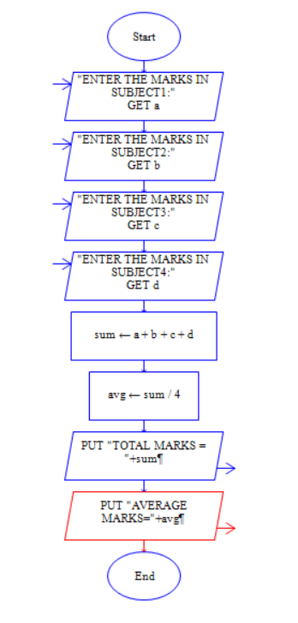

6.PERFORM ARITHEMATIC OPERATIONS OF ANY TWO NUMBERS:

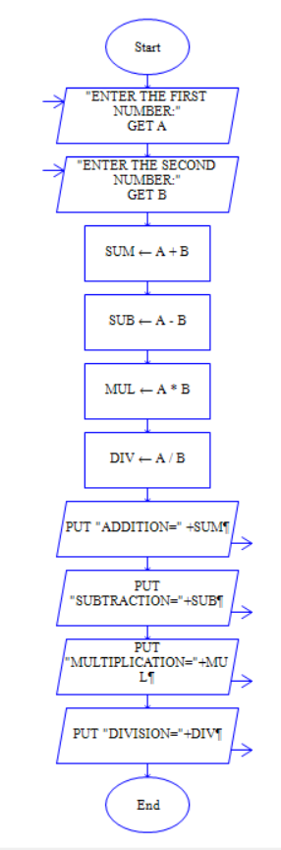

7.TO PRINT N NATURAL NUMBERS:

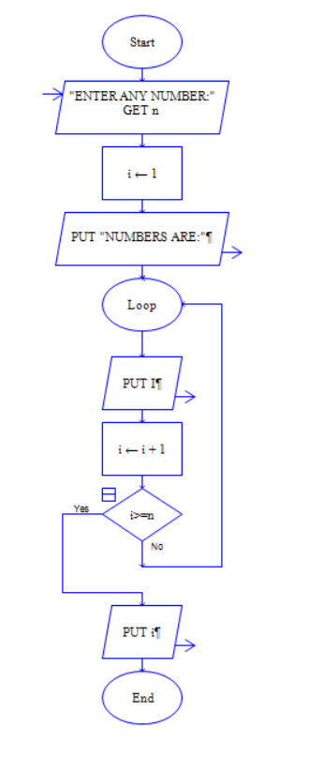

8.TO FIND THE GIVEN NUMBER IS PALINDROME OR NOT:

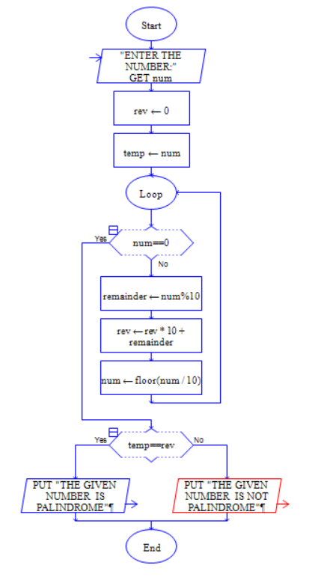

9.TO CONVERT A NUMBER FROM OCTAL TO DECIMAL:

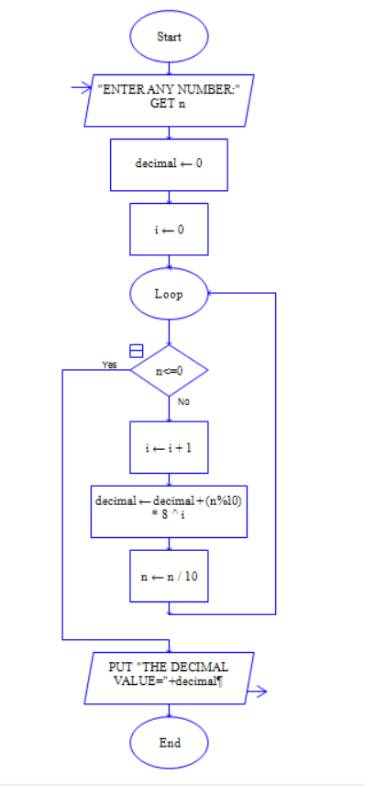

10.TO SOLVE A QUADRATIC EQUATION:

